**Homework 13**

**Casey Sorrells**

1) Integrated package of tools to allow a software developer to create application.

2) A project is a container that holds a bunch of related files like .java, .class, .cpp etc.

3) File 🡪 New 🡪 Project... inside the wizard, expand the Java folder and select "Java Project", then click 'Next'.

4) Under the Package Explorer section of the Eclipse IDE, right click on the name of the project, and select New --> class

5) Under the Package Explorer section of the Eclipse IDE, double click the .java file you wish to view/edit.

6) The Code Completion Dialog box. The box contains a list of everything you can type next.

7) The Wavy red line highlights a typo, or incomplete statement.

8) A syntax error, the compiler doesn’t understand this line.

9) Menu 🡪 Run 🡪 Debug

10) A debugger lets you pause/stop/brake a program. You tell the debugger where you want to pause/stop/brake the program.

11) Right-click on the left edge where the line numbers are, select “toggle breakpoint”.

12) A breakpoint. This is where the program will stop/pause/break.

13) The arrow shows where the debugger stopped. It has not executed this line yet.

14) While a program is paused/stopped in debugger mode, hold the cursor over the variable name, a box will pop up showing its current value.

15) Menu 🡪 Run 🡪 Step over

16) Menu 🡪 Run 🡪 Resume

17) Menu 🡪 run 🡪 Terminate

18) Right-click on the left edge where the line numbers are, select “Toggle breakpoint”.

19)

A: 2nd from left

B: 4th from left

C: 7th from left

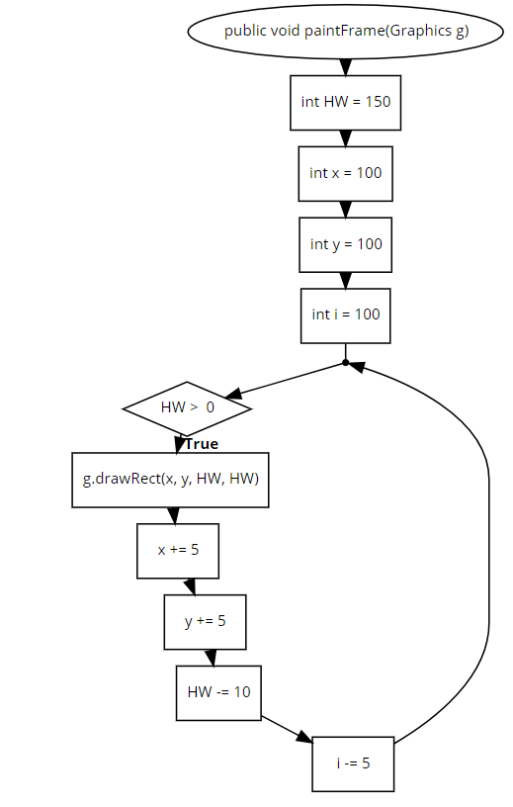20)

21)

public void paintFrame(Graphics g) {

int HW = 150;

int x = 100;

int y = 100;

for (int i = 100; HW > 0; i -= 5) {

g.drawRect(x, y, HW, HW);

x += 5;

y += 5;

HW -= 10;

}

}



22) TEST PLAN:

DO YOU SEE THIS? [ ]

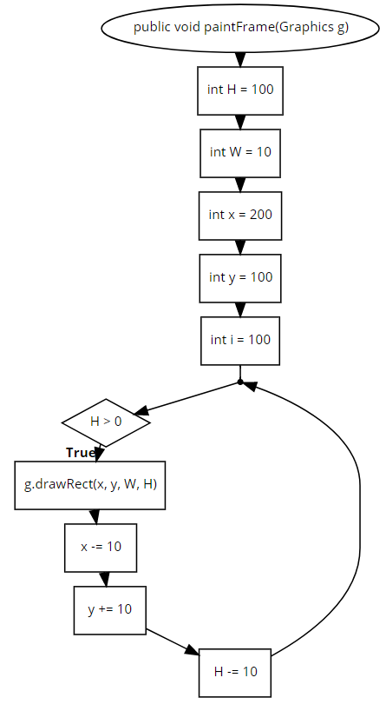

23)

24)

public void paintFrame(Graphics g) {

int H = 100;

int W = 10;

int x = 200;

int y = 100;

for (int i = 100; H > 0; H -= 10) {

g.drawRect(x, y, W, H);

x -= 10;

y += 10;

}

}

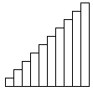25) TEST PLAN:

DO YOU SEE THIS: [ ]

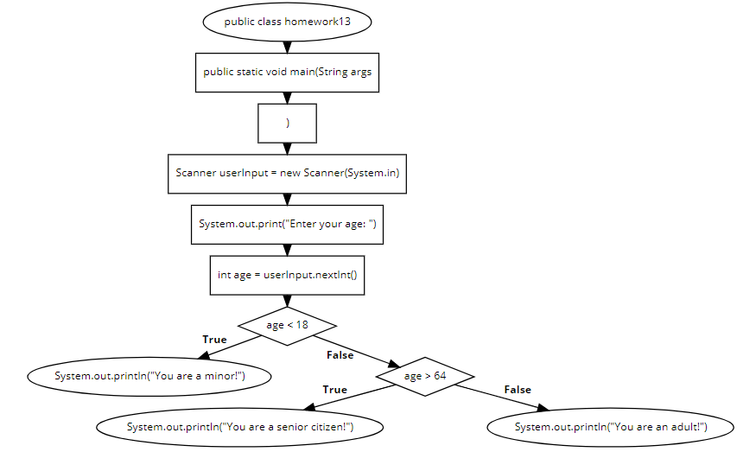26)

27)

import java.util.*;

public class homework13 {

public static void main(String args[]) {

Scanner userInput = new Scanner(System.in);

System.out.print("Enter your age: ");

int age = userInput.nextInt();

if (age < 18) {

System.out.println("You are a minor!");

} else if (age > 64) {

System.out.println("You are a senior citizen!");

} else {

System.out.println("You are an adult!");

}

}

}

28) TEST PLAN:

USER ENTERS 12, OUTPUT: MINOR [ ]

USER ENTERS 17, OUTPUT: MINOR [ ]

USER ENTERS 18, OUTPUT: ADULT [ ]

USER ENTERS 64, OUTPUT: ADULT [ ]

USER ENTERS 65, OUTPUT: SENIOR [ ]

USER ENTERS 95, OUTPUT: SENIOR [ ]